Top Circular Rim
# Source: AI Source: Provided by: [Data Path: Persons Table -> ID Column: 1, Name_En Column: Motasem Essam] -> From: [ChatGPT] on [7/25/2026]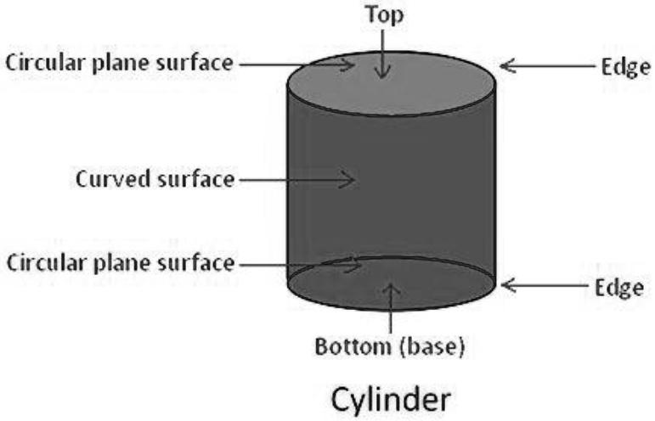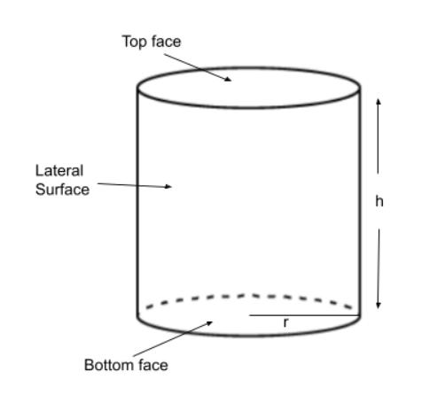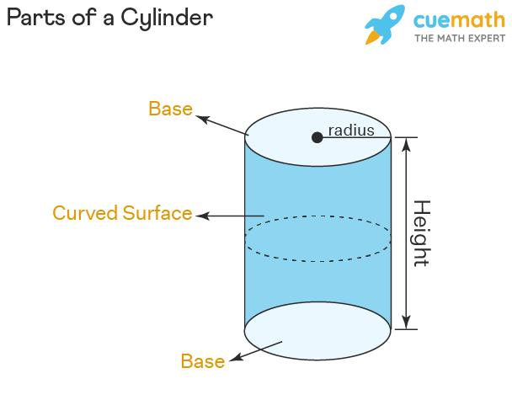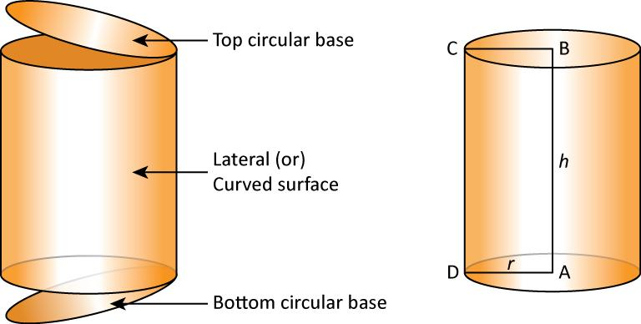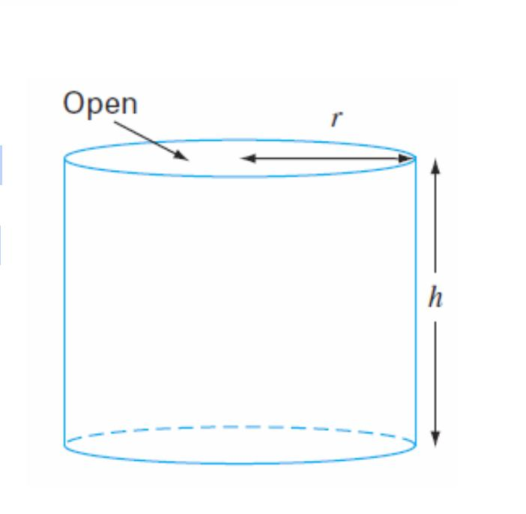

Definition
# Source: AI Source: Provided by: [Data Path: Persons Table -> ID Column: 1, Name_En Column: Motasem Essam] -> From: [ChatGPT] on [7/25/2026]
The top circular rim of a cylinder is the circular boundary at the upper end of the cylinder, surrounding its top base.
For a solid right circular cylinder, the top rim is the circular edge bounding the upper circular base. For a hollow cylinder, the upper end may have two circular rims: an outer rim and an inner rim, which bound the annular top face.
- Position: Upper end of the cylinder.
- Shape: Circular.
- Role: Marks the boundary of the top base or upper opening.
- Related dimensions: Radius, diameter, circumference, and—if hollow—wall thickness.

Simple Definition
# Source: AI Source: Provided by: [Data Path: Persons Table -> ID Column: 1, Name_En Column: Motasem Essam] -> From: [ChatGPT] on [7/25/2026]
The top circular rim is the circular edge around the top of a cylinder.

Geometric Representation
# Source: AI Source: Provided by: [Data Path: Persons Table -> ID Column: 1, Name_En Column: Motasem Essam] -> From: [ChatGPT] on [7/25/2026]
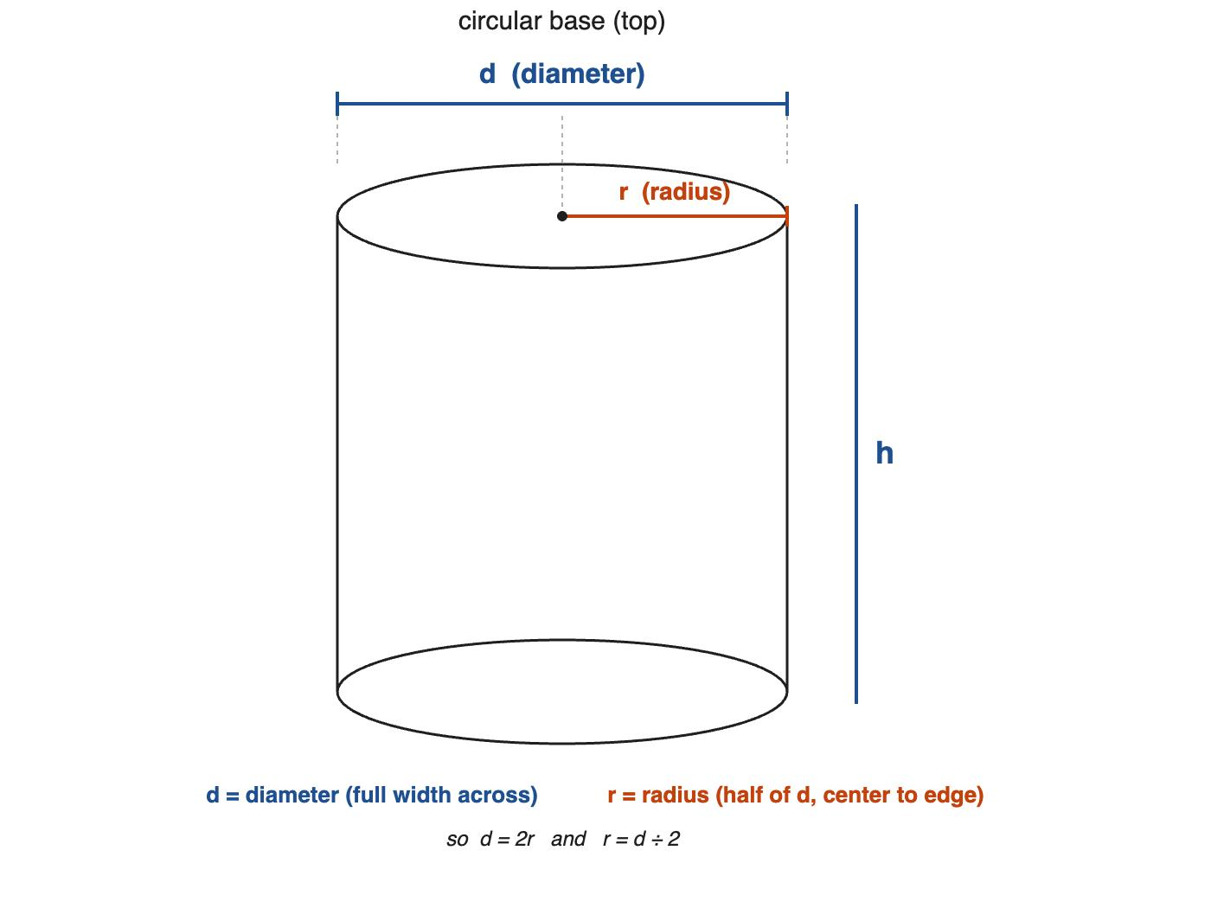
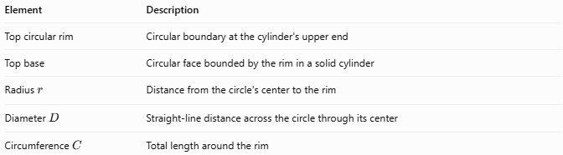
Element | Description
Top circular rim | Circular boundary at the cylinder's upper end
Top base | Circular face bounded by the rim in a solid cylinder
Radius $r$ | Distance from the circle's center to the rim
Diameter $D$ | Straight-line distance across the circle through its center
Circumference $C$ | Total length around the rim
For a solid cylinder, the top rim bounds the top circular face. For a hollow cylinder, the top end is an annular face bounded by both an outer and an inner circular rim.

Types of Top Circular Rims

Top Rim of a Solid Cylinder
# Source: AI Source: Provided by: [Data Path: Persons Table -> ID Column: 1, Name_En Column: Motasem Essam] -> From: [ChatGPT] on [7/25/2026]
The single circular boundary surrounding the solid cylinder's top base.

Outer Top Circular Rim
# Source: AI Source: Provided by: [Data Path: Persons Table -> ID Column: 1, Name_En Column: Motasem Essam] -> From: [ChatGPT] on [7/25/2026]
The larger circular boundary around the outside of a hollow cylinder's upper end.
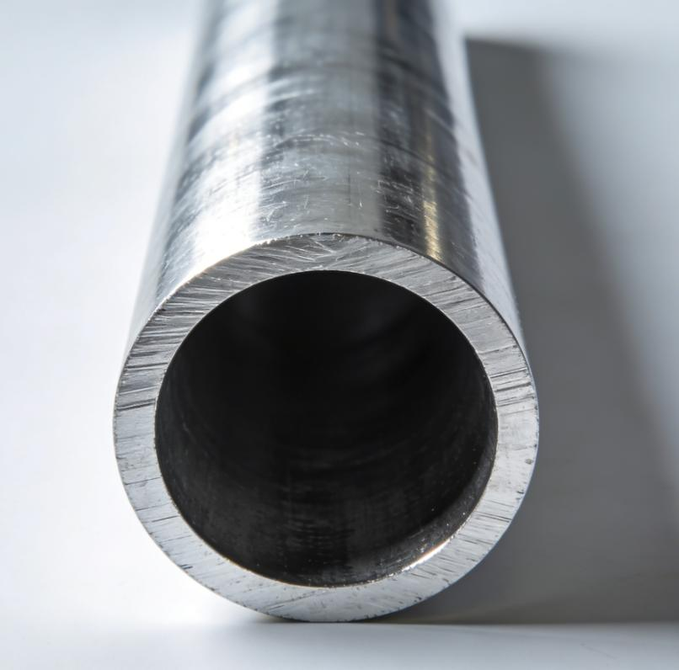

Inner Top Circular Rim
# Source: AI Source: Provided by: [Data Path: Persons Table -> ID Column: 1, Name_En Column: Motasem Essam] -> From: [ChatGPT] on [7/25/2026]
The smaller circular boundary around the hollow opening at the upper end of a tube.
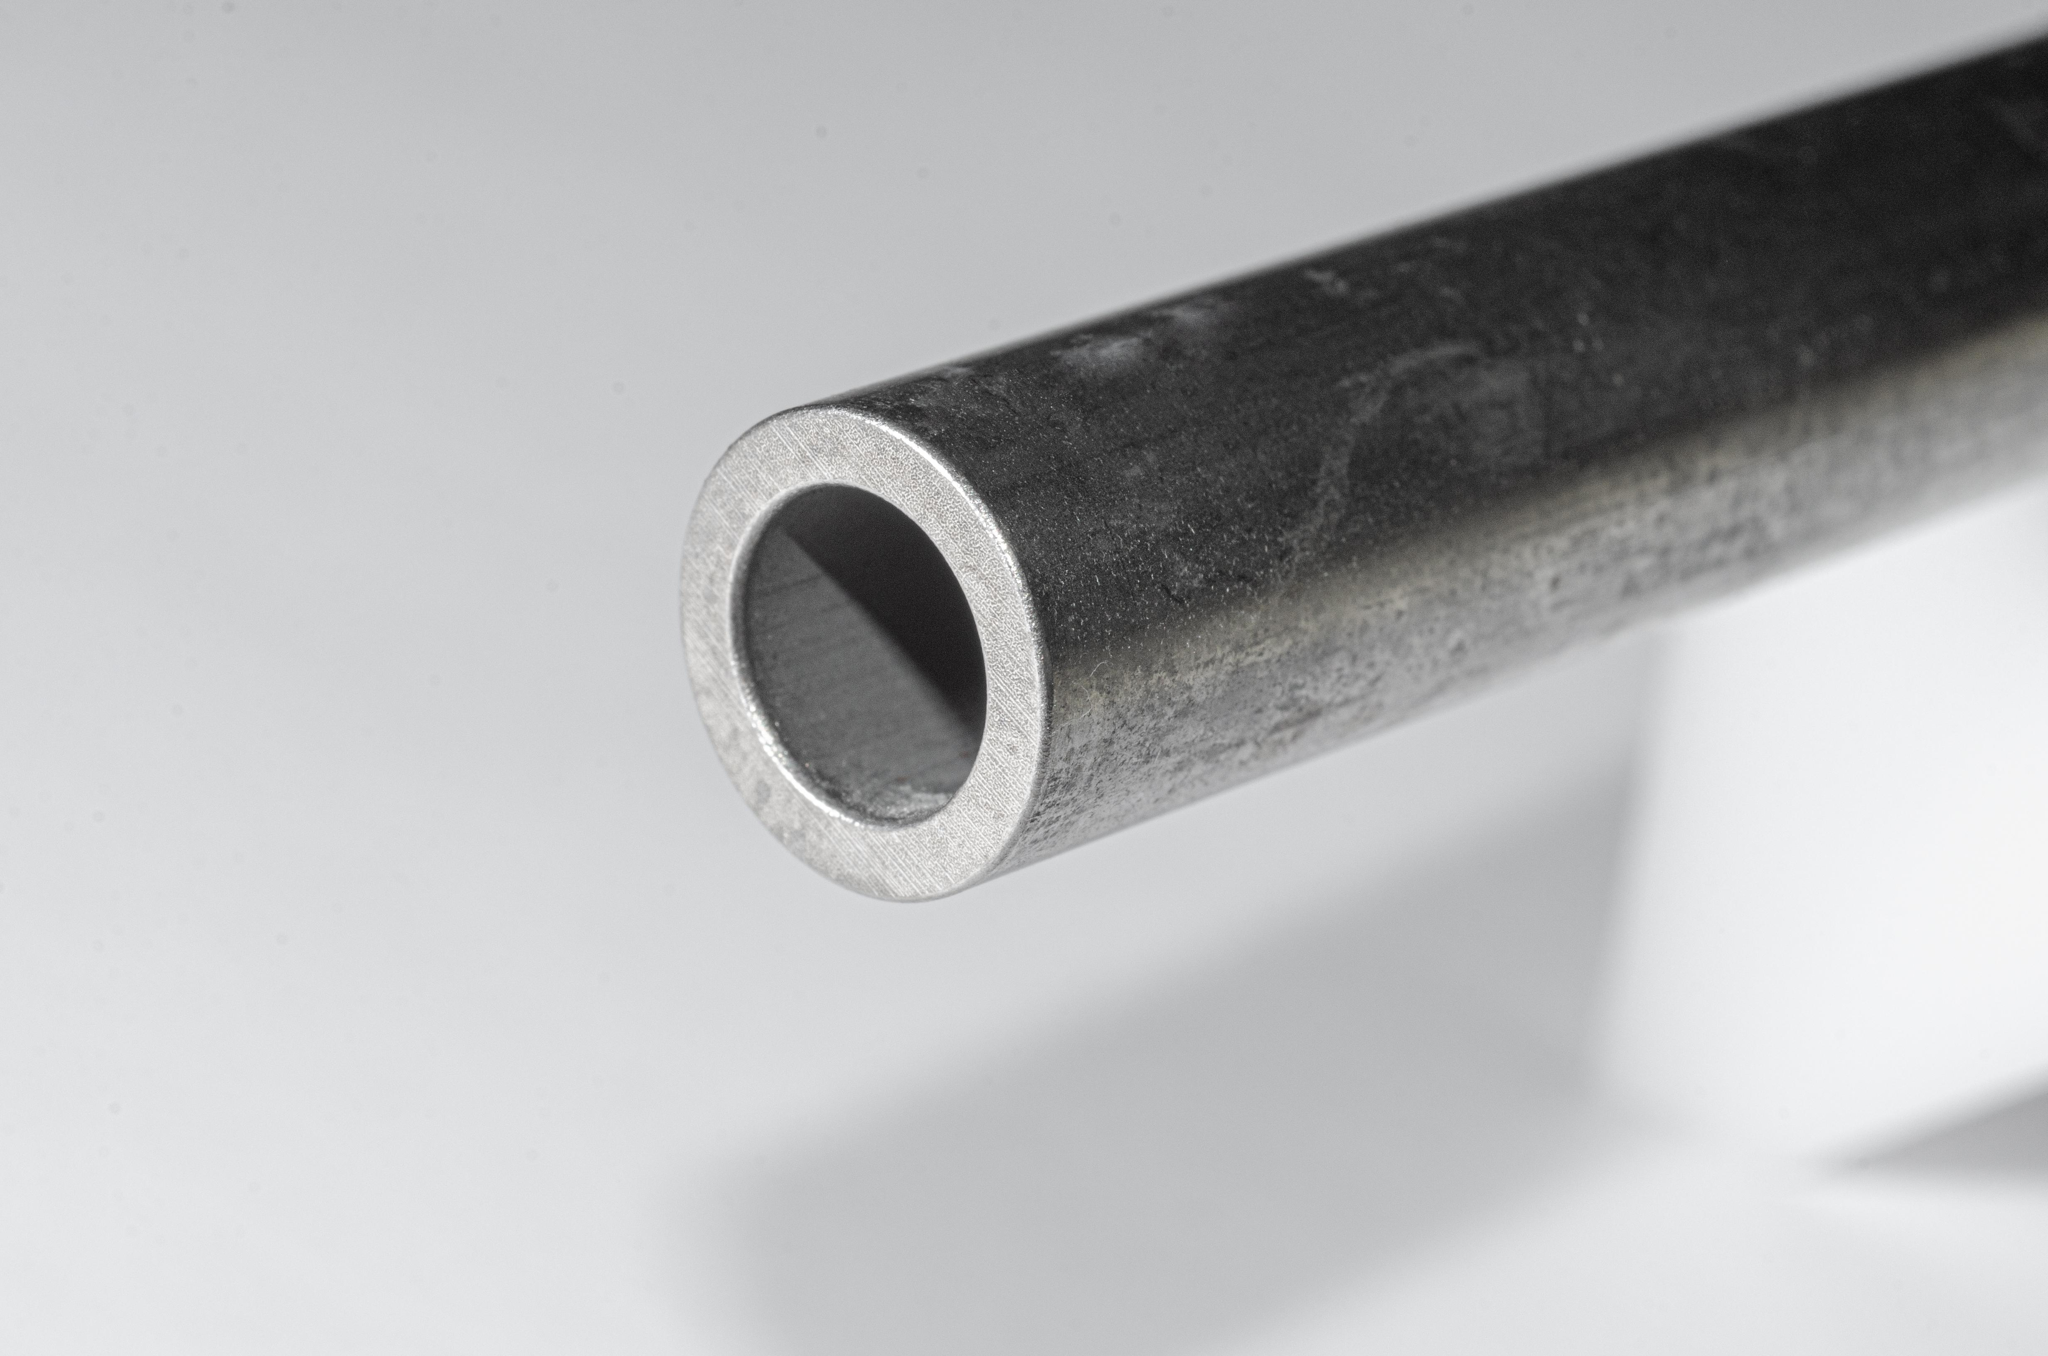

Mathematical Properties and Formulas

Circumference of the top circular rim
# Source: AI Source: Provided by: [Data Path: Persons Table -> ID Column: 1, Name_En Column: Motasem Essam] -> From: [ChatGPT] on [7/25/2026]
The length of the top circular rim of a solid cylinder is:
$$\boxed{C=2πr}$$
Using the diameter $D=2r$:
$$\boxed{C=πD}$$
For a hollow cylinder, the outer and inner rim circumferences are:
$$C_{o}=2πR$$
$$C_{i}=2πr$$
where $R$ is the outer radius and $r$ is the inner radius.

Length of the rim and top-base area
# Source: AI Source: Provided by: [Data Path: Persons Table -> ID Column: 1, Name_En Column: Motasem Essam] -> From: [ChatGPT] on [7/25/2026]
The area of the circular top base of a solid cylinder is:
$$\boxed{A=πr^{2}}$$
The rim itself is a one-dimensional circular boundary, so it has a circumference, not a surface area.
For a hollow cylinder, the area of the annular top face is:
$$\boxed{A=π(R^{2}-r^{2})}$$

Relationship between the rim and the cylinder's height
# Source: AI Source: Provided by: [Data Path: Persons Table -> ID Column: 1, Name_En Column: Motasem Essam] -> From: [ChatGPT] on [7/25/2026]
The top rim is located at the upper end of the cylinder, while the height measures the perpendicular distance between the base planes.
For a right circular cylinder, the top and bottom rims lie in parallel planes separated by height $h$.

Worked Examples

Example 1 — Find the circumference of a top rim
# Source: AI Source: Provided by: [Data Path: Persons Table -> ID Column: 1, Name_En Column: Motasem Essam] -> From: [ChatGPT] on [7/25/2026]
A solid cylinder has a top-base radius of $4 cm$. Find the circumference of its top rim.
Solution:
$$C=2πr$$
$$C=2π(4)$$
$$\boxed{C=8π cm≈25.13 cm}$$

Example 2 — Find the diameter from the rim circumference
# Source: AI Source: Provided by: [Data Path: Persons Table -> ID Column: 1, Name_En Column: Motasem Essam] -> From: [ChatGPT] on [7/25/2026]
The top circular rim of a cylinder has a circumference of $18π cm$. Find its diameter.
Solution:
$$D=\frac{C}{π}$$
$$D=\frac{18π}{π}$$
$$\boxed{D=18 cm}$$

Example 3 — Find the annular top-face area
# Source: AI Source: Provided by: [Data Path: Persons Table -> ID Column: 1, Name_En Column: Motasem Essam] -> From: [ChatGPT] on [7/25/2026]
A hollow cylinder has an outer top-rim radius of $5 cm$ and an inner top-rim radius of $3 cm$. Find the area of its top annular face.
Solution:
$$A=π(R^{2}-r^{2})$$
$$A=π(5^{2}-3^{2})=π(25-9)$$
$$\boxed{A=16π{ cm}^{2}≈50.27{ cm}^{2}}$$

Comparison with Related Concepts
# Source: AI Source: Provided by: [Data Path: Persons Table -> ID Column: 1, Name_En Column: Motasem Essam] -> From: [ChatGPT] on [7/25/2026]
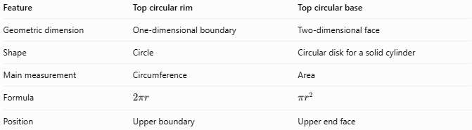
Feature | Top circular rim | Top circular base
Geometric dimension | One-dimensional boundary | Two-dimensional face
Shape | Circle | Circular disk for a solid cylinder
Main measurement | Circumference | Area
Formula | $$2πr$$ | $$πr^{2}$$
Position | Upper boundary | Upper end face
For a hollow cylinder, the top face is annular rather than a complete disk, and it has two boundaries: an outer rim and an inner rim.

Applications
# Source: AI Source: Provided by: [Data Path: Persons Table -> ID Column: 1, Name_En Column: Motasem Essam] -> From: [ChatGPT] on [7/25/2026]
Top circular rims are important in:
- Designing the edges of cylindrical containers and cans.
- Measuring the circumference of pipe openings.
- Determining the dimensions of lids and covers.
- Calculating the area of annular ends on hollow tubes.
- Describing the boundary geometry of cylindrical mechanical parts.

Key Points
# Source: AI Source: Provided by: [Data Path: Persons Table -> ID Column: 1, Name_En Column: Motasem Essam] -> From: [ChatGPT] on [7/25/2026]
- The top circular rim is the circular boundary at the upper end of a cylinder.
- Its circumference is $C=2πr=πD$.
- The rim is not the same as the top base; the rim is the boundary, while the base is the face.
- A solid cylinder has one top circular rim.
- A hollow cylinder generally has an outer top rim and an inner top rim.
- The area of a hollow cylinder's top annular face is $π(R^{2}-r^{2})$.

Conclusion
# Source: AI Source: Provided by: [Data Path: Persons Table -> ID Column: 1, Name_En Column: Motasem Essam] -> From: [ChatGPT] on [7/25/2026]
The top circular rim is the circular boundary surrounding the upper end of a cylinder. It defines the edge of the top base or opening and can be described using its radius, diameter, and circumference. In hollow cylinders, the outer and inner top rims define the boundaries of the annular end face.

